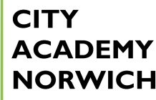

Careers, Advice, Education, Information & Guidance (CAEIG) Policy

Date: Sept 2026
Review date: annually or as required by statutory guidance updates and/or Ofsted reports.

CEIAG Vision
Our progressive CEIAG programme at City Academy Norwich provides pupils with a wide range of experiences to help them progress effectively through their education and onto successful careers. It is integrated into students’ experience of the whole curriculum. Based on a partnership with students and their parents and carers, the programme is organised to raise aspirations, challenge stereotyping and promote equality and diversity. It offers a wide variety of learning opportunities to all our students from Year 7 to Year 11. It enables our young people to find purpose, discover what matters to them and identify their place in the world. A key goal of our careers programme is to give our students hope, meaning, purpose and character to enable them to navigate the challenges they will face in life and develop the knowledge, confidence and skills needed to ensure a smooth transition from school into their chosen career pathway and ultimately to realise their full potential.

City Academy Norwich recognises the essential part careers education, information advice and guidance play in preparing students for future pathways and the responsibilities of adult and working life.

City Academy Norwich CEIAG vision aligns directly with the whole school vision, mission statement, curriculum intent and development priorities This mission statement is Every Child, Same Chance. We strive for every child to have the same chance in life. We aim to enable all students to become the very best versions of themselves, by providing exceptional education and opportunity in an environment of high expectation and aspiration.

City Academy Norwich was recognised by Ofsted 2024 as a school which
‘’provides an appropriate programme of personal, social, health and economic education.
This includes the delivery of effective careers education. Pupils typically gain a lot from this.’’

Quality in Careers
Career describes our full journey through life, learning and work. City Academy Norwich ensures that it’s comprehensive careers programme is subject to quality assurance procedures.

City Academy Norwich has an embedded programme of careers education and guidance that
is understood by all and has the backing of the Senior Leadership Team. It is led by Mrs. C Land (Careers Lead), who is line managed by Mr J Lowden (SLT).

The Careers Plan is published on the website. It is evaluated regularly with feedback from pupils and our Enterprise Adviser from the Anglia Careers Hub.
Students can access information about careers in the library, Careers TEAMS, website, and noticeboards throughout the academy. Unifrog is being integrated into the school to provide students with on demand access to their CAIEG session notes.

School leadership also gives CPD time to delivering sessions focused on CAIEG.

Framework
Using the Gatsby Benchmarks our aim is to provide information, advice, and guidance (IAG) which is impartial, unbiased, and focused on the individual needs of our student
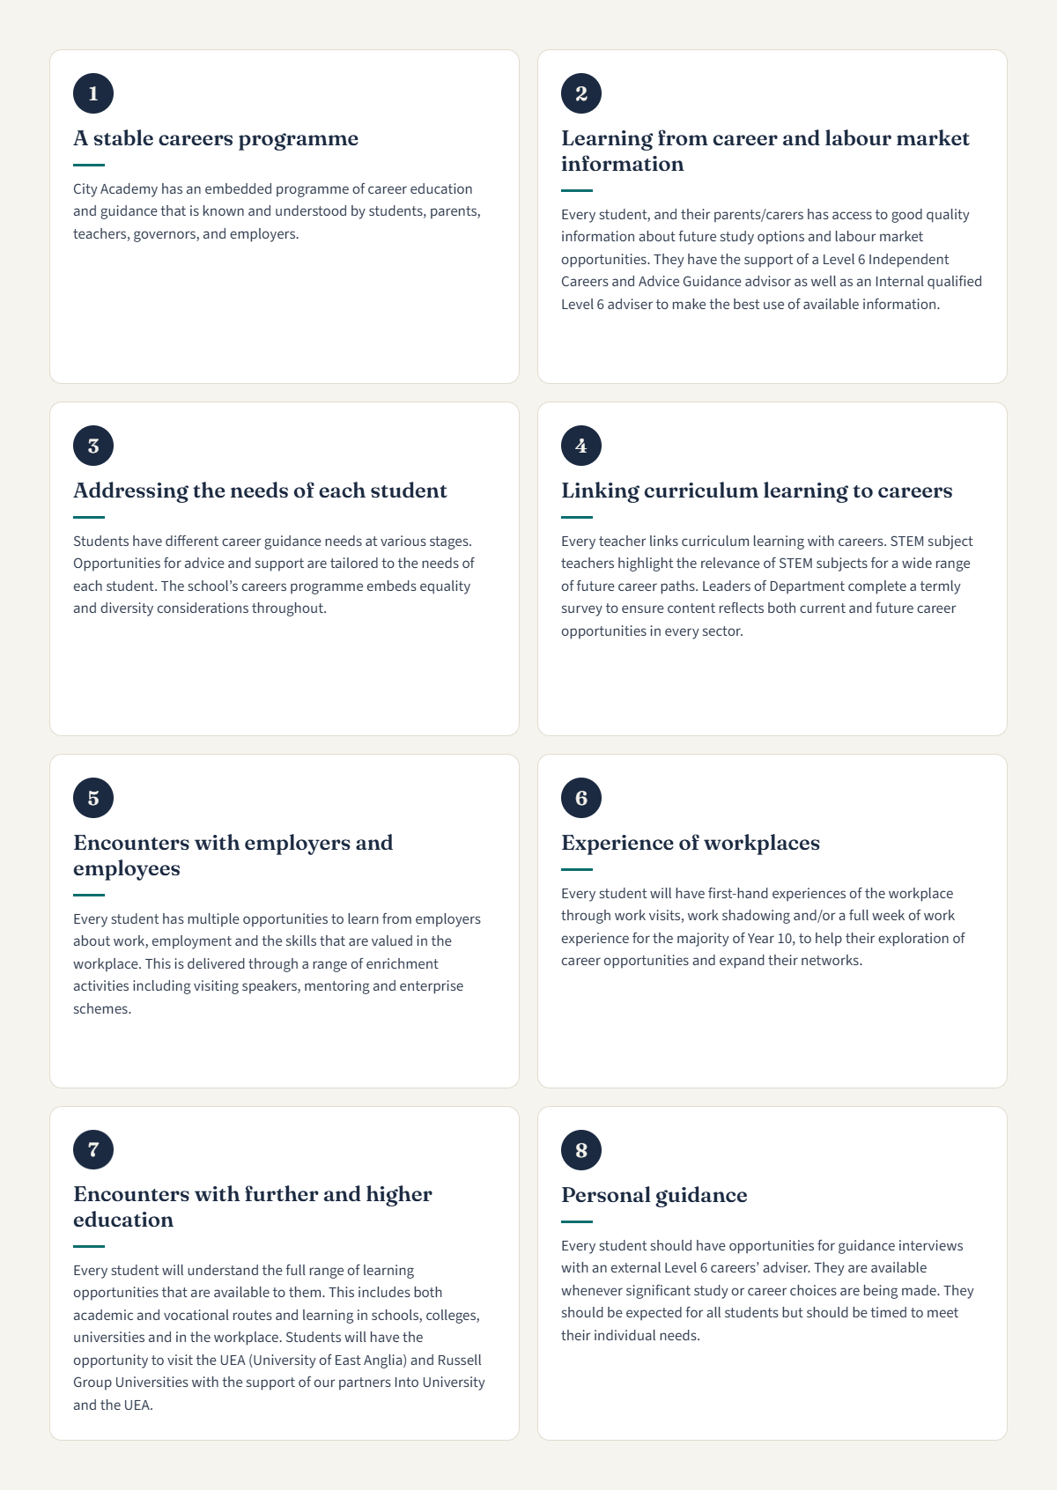

Objectives
Year 7
By the end of Year 7, students will begin to develop key employability skills and start to think about their future ambitions. Students will engage with employers in many opportunities
including co-curricular, activities week and trips/visits.

Year 8
By the end of Year 8, students will begin to develop key employability skills and start to think
about their future ambitions. Students will engage with a few external providers to learn about pathways and continue to develop key employability skills with a particular focus on teamwork and resilience.

Year 9
By the end of Year 9, students will be able to recognise the different pathways for post-16 and post-18 as well as becoming confident in understanding Labour Market Information. Students begin to make decisions about their future and identify areas of interest to research and explore career pathways independently. In line with Modern Work Experience, by the end of Key Stage 3 all of our students will be offered one week of meaningful work experience activities.

Year 10
By the end of Year 10, students will develop a further understanding of post-16 options and how to present in an interview situation. Students will generate own Work Experience placements and engage with recruitment process including application forms, interviews, CV building. In line with Modern Work Experience, by the end of year 10 all our students will be supported to undertake one week of meaningful work placements.

Year 11
Students will be able to make informed choices about their post-16 future. Students will understand the application processes for Sixth Forms, Colleges, work related learning and apprenticeships. They will compile their CV and build confidence in an interview situation. Every student will apply and have a Post 16 pathway in place before they leave Year 11.

Year by Year Activities

Year | Autumn term | Spring term | Summer term
7 | Careers & Your Future | Breaking Down Stereotypes | Transition Points and Your Life
8 | Employability & Enterprise | Transferable skills | Gender equality
9 | Next steps Post 16 | Choosing options | Employability skills
10 | Preparation for Work Experience | Exploring post 16 pathways | Employability skills
11 | Help You Choose (Applications for Post 16) | Interview skills financial capability

Stakeholders
The Careers programme is published on the Academy website.
Students can access Careers Information on TEAMS in the Library and noticeboards throughout the academy.
We publish a termly Careers Newsletter emailed to parents, carers, and our stakeholders.
In Year 10 and Year 11, Raising Achievement evenings are held for students, parents, and carers to engage with post-16 providers across every sector.

In Year 10 we hold a Work Experience information evening for students/parents/carers to understand the applications process, purpose and value work experience can make to our students.

Once a year we hold an in-house Careers fair, every student will meet post-16, post-18 providers and employers to enable them to explore the career opportunities available within each sector.

Partners
  - Access Creative College
  - Business In the Community (The Princes Responsible Network)
  - City College Norwich
  - Easton College
  - Into University
  - NEACO (UEA)
  - Nova Training
  - Paston College
  - Poultec
  - University of East Anglia
  - UTCN
  - EEEGR
  - Barnhale
  - Sir Isaac Newton Sixth Form
  - Jayne Austen Sixth Form
  - Hellesdon Sixth Form
  - Ormiston Victory Academy
  - Norfolk Apprenticeships
  - Dereham Education & Soccer Academy
  - Aviva
  - Notre Dame High School
  - KLM

Student Entitlement/Goals for Students
All students are entitled to and will receive impartial and independent career education advice and guidance which will inform their longer-term career goal. We will do this by:

- Helping students learn to understand themselves and develop their capabilities.
- Raise students’ self-esteem and confidence which will allow them to realise their true potential.
- Develop an understanding of the range of opportunities available at each transitional stage including technical education routes and Apprenticeships.
- Supporting inclusion, challenging stereotyping, and promoting equality of opportunities.
- Enabling students to explore careers through employer encounters, online resources, and careers programme
- Help students manage their career planning by giving them the tools which will enable them to make decisions based on interests and abilities and labour market information.
- To raise aspiration and prevent disengagement from the learning process and students becoming NEET (not in Employment, Education or Training).
- To provide the opportunity for students to learn about STEM (Science Technology,
Engineering and Maths) related careers. To have encounters with employers and workplaces related to STEM; to encourage proactive links with curriculum subjects.

Monitoring and Evaluation
We use COMPASS Plus to monitor our progress against the eight Gatsby Benchmarks each term.
The school Careers Adviser is Mr Fred Lavery (Sapientia Education Trust), who meets with our students in Years 10 and 11 for one-to-one Careers Guidance. Mr Lavery provides feedback for Mrs Land each week to ensure each student's needs are met according to their individual needs. This feedback is shared with the Careers Lead SLT link.
Our student voice panel meets termly to discuss Careers provision. Students complete the annual careers survey every academic year.
Staff complete an annual careers survey at the end of each academic year.
We distribute a termly careers segment in our whole school newsletter that is E mailed to parents and carers and our stakeholders.
Leaver's destinations are published on our website.
We have an Annual Trust visit looking at Gatsby Benchmarks and the quality of evidence used to rate ourselves against each Gatsby Benchmark on Compass Plus.

Personnel and Contact Details:
The school Careers Adviser is Mr Fred Lavery (Sapientia Education Trust), who meets with our students in Years 10 and 11 for one-to-one Carers Guidance.
The school Careers Lead is Mrs Charlotte Land (Leader of Personal development and Enterprise) whose role includes:
- The tracking of the activities, their effectiveness and feedback from them which feeds into our school evidence base for our tracking on compass +.
- Produce and oversee the assembly programme and personal development aspects of the tutor programme
- Responsible for leading the development of a PSHE (Personal, Social, Health and
Economic) / RSE programme of activities for Years 7 to 11, liaising with staff responsible for the delivery of outstanding Personal Development and Enterprise responsible for creating and implementing the careers guidance development plan
The Trust Careers Lead is Kirsty Bray (Kirsty.bray@setrust.co.uk) her role is to support the
school's source and deliver a careers programme that meets the Gatsby Benchmarks, working with external parties as required and coordinating termly meetings of school careers leads to share pertinent and relevant information that can be drawn into each school’s careers programme. The Trust arranges, with each career lead, an annual careers audit and review and a short-written report against the Gatsby Benchmarks is produced.

The Trustee with Careers oversight: contact clerk to the Trustees, Wendy Maguire w.maguire@setrust.co.uk

